Building A Regionally Inclusive Dictionary For Speech Recognition

Justin Andre Burdick, Keyvan Mohajer, Vaughan Pratt

Department of Electrical Engineering, Stanford University

ABSTRACT

In this paper, our goal is to create a more speaker independent SR system by taking into account that different speakers may pronounce similar words differently. This requires building a dictionary that possibly has multiple pronunciations for any given word. However, care must be taken to choose what level of multiple pronunciations is included in the dictionary. By finding the optimal number of pronunciations per word, we were able to obtain an increase in accuracy of 7.7% over our basic dictionary (from 78% to 85.7%), taking us 35% closer to full recognition.

Speech recognition, Dictionary, Dialects, Speaker Independent Speech Recognition

- INTRODUCTION

Speech Recognition (SR), the automated conversion of speech into written text, has many applications. The largest commercial applications include airline phone reservation systems, as well as information. Generally, almost any repetitive phone task can use speech recognition to automate the process, saving business large amounts in wages. However, the task of speech recognition is easiest for applications where the task is very straightforward, and containing only a small possible set of responses (‘dictionary’).
A complete Speech Recognition (SR) system is fairly complex. It consists of various subsystems that interact together to convert sound waves into written text. Figure 1 shows a simplified model of a typical SR system that uses Hidden Markov Models (HMM) to model speech [1]. Hidden Markov Models are a very commonly used tool for doing pattern matching. Each model consists of a “mean” vector (a set of average values), and a variation vector. With these two lists of information, one can generate a probability of this model matching any observed speech segment.
The models are first trained using a set of training data. The training data consists of (usually) a large number of wave sound files and their corresponding transcriptions. These sounds files are converted to series of observation (“feature”) vectors (a set of numbers which describes a sound) by extracting the Mel-Frequency-Cepstrum-Coefficients (MFCC) every 25 milliseconds. The computer can match these numerical representations of the speaker’s voice to the hand-made transcription of what they said to create a series of models for what each element of speech sounds like. When the training process is complete, a text file representing each sub-word (phoneme) in the system sounds like is generated. These files contain the mean and variation vectors, as well as transition probabilities between various phonemes. Another file which is needed by the recognition system is the “pronouncing” dictionary. This dictionary contains all the words used in the training file, and contains the sequence of phonemes which make up each word.
Once the models are trained, the system can perform testing (recognition). In order to produce meaningful sentences as the output, the recognition needs to rely on a dictionary and a grammar model. In the recognition system, the Vitterbi algorithm is used. This algorithm processes one observation at a time, and explores the probability of that observation matching every possible phoneme. When the algorithm moves to the next observation, it eliminates those paths that have a low probability. In this way, only the most probable paths survive until the end of the observation sequence, and the recognized words can then be generated. The dictionary is important in this process because as the system moves through processing observations, it must check the dictionary to see if it has made a word yet. Once the word is made, the system can employ the grammar file to influence the next word chosen, which is very valuable for making the sentence actually meaningful (similar to grammar check in a word-processing program).

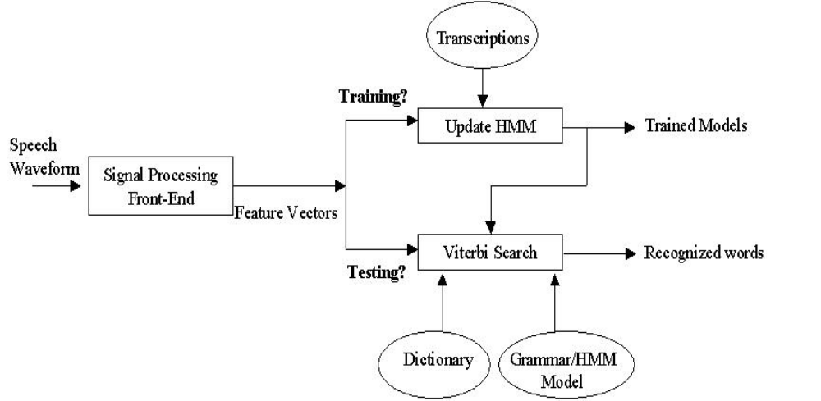

Figure 1. An oversimplified model of an HMM-based speech recognition system

The multidisciplinary nature of the SR systems should now be apparent. Although the details in the description of Figure 1 are omitted, one can appreciate the importance of the following areas in this field:

- Signal Processing (for extracting important features from the sound waves)
- Probability and Statistics (for defining and training the models and recognition)
- Linguistics (for building the dictionary and the grammar)
- Computer Science (for creating efficient search algorithms)

Improvements in any of the subsystems above could result in better overall performance. The following performance measures are among the main objectives of any SR system[2]:

- Increased Accuracy (lower error rate): This value is measured as a percentage of words (or sentences) that are correctly detected. To emphasize the importance of this value, consider a certain SR system that has an accuracy of 99%. This means that during the task of dictation, 1 word in every 100 words is identified incorrectly. For the average dictation, that would result in approximately 6 errors per page. The user then has to search for these errors and correct them, a tedious and time-consuming task. This shows that even an accuracy of 99% may not be sufficiently high enough for the task of dictation.

- Increased Speed: Many speech recognition applications must run on small hand-held computers with limited CPU power. It is important for the SR system to be as computationally simple as possible. This will allow it to keep up with a normal speech speed even on low-performance systems like PDAs.

- Speaker Independence: Most SR systems can operate with very high accuracy if they are trained (adapted) to a specific speaker. However, they may not perform as well with other speakers. The reasons for this include (but are not limited to):

  - Different speakers may pronounce similar phonemes (sub-words) differently. i.e. a speaker from Brooklyn would pronounce certain vowels differently than a speaker from California.
  - Different speakers may pronounce the same words differently (with different sequence of sub-words). I.e.: maybe as “m ey b iy” or as “m ey v iy” note the similarity between ‘b’ and ‘v.’

In this project, our goal is to create a more speaker independent SR system by taking into account that different speakers may pronounce similar words differently. This requires building a dictionary that possibly has multiple pronunciations for any given word. The details of building such a dictionary are explained in section 2 below. In order to test the affects of this approach, a set of carefully designed experiments were conducted. Section 3 describes the experimental setup, and section 4 presents the results and analysis followed by the conclusions in section 5.
Sample file: Entire Sentence and total length
0 62055 As coauthors, we presented our new book to the haughty audience.
Sx160.wrd file: The timing of each word
2297 5096 as
5096 15749 coauthors
16760 18360 we
18360 25817 presented
25817 28156 our
28156 30704 new
30704 35642 book
41586 43257 to
43257 45095 the
45095 50150 haughty
50610 60200 audience
Sx160.phn file: The timing for each phoneme
2297 2757 q
2757 3968 eh
3968 5096 z
5096 5713 kcl
5713 6600 k
6600 9023 ow
9023 11560 ao
11560 12866 th
12866 14440 axr
14440 15749 z
…(continued)…
Figure 2: Building a dictionary from the transcription files

- BUILDING THE DICTIONARY
How the dictionary was made
This speech recognition project used the TIMIT (Texas Instruments- Massachusetts Institute of Technology) database for both training and testing. This database contains audio files of sample sentences, as well as a word-level transcription and a phoneme-level transcription. Although TIMIT provides a dictionary for the words used in the samples, it incongruously does not use the same set of phonemes as the transcriptions do. To fix this problem, the TIMIT time-aligned phonetic transcriptions were carefully edited to reduce the number of phonemes to 43[1]. Furthermore, we needed to create our own dictionary before we could do training and recognition. To do this, our group wrote a Perl script that searches through all word/phoneme-level transcription files in TIMIT. Using the time boundary information stored in the files, we can match up the word that happens in a certain time frame to the phonemes that happen in the same time frame, creating a mapping between word and definition. See below for an example of the process:
Example set of files:
This is a sample TIMIT data file. Here, we match the word “as” (time samples 2297-5096) to the 3 phonemes q, eh, and z. Since q starts at time 2297, and z ends at 5096, we know we have captured the entire sequence for the word “as”.
Hence, we can see that for our method of dictionary creation, the following would be output:
As | q eh z
Coauthors | kcl k ow ao th axr z
Table 1 Sample dictionary entries made by checking time boundaries.
Information about TIMIT:

The complete TIMIT corpus was used in the experiments. About 70% of the TIMIT data is used for training the HMM models, and a further 30% is used for testing [4]. Some important facts about the TIMIT database are presented in Table 3.

No. of speakers | 630 (70% male, 30% female)
No. of utterances | 6300 (10 per speaker)
No. of distinct texts | 2342
No. of words | 6099
No of utterances in the training set | 4620
No. of utterances in the test set | 1680
No. of male speakers | 326 (training set) + 112 (test set)
No. of female speakers | 136 (training set) + 56 (test set)
Table 3. Important facts about the TIMIT Corpus

Problems with this method:
In order to provide a versatile training set, data was collected from speakers from 8 different language backgrounds to capture regional dialects [4] (shown in figure 3). However, these regional dialects introduce problems for making a dictionary. Since many of the speakers pronounce words differently (especially prevalent with short, common words), multiple transcriptions for the same word were very common. The new dictionary contained on average 2 pronunciations per word, for the total of 6099 words in the entire corpus [1]. However, the dictionary is laid out such that many words have only one pronunciation, while other words have a half-dozen or more. A certain level of multiple pronunciations can be helpful at capturing a common divergence in pronunciation (i.e. potato/potăto). Even some of the best hand-made dictionaries contain 1.1 to 1.2 pronunciations per word [5]. However, having too many multiples could be misleading when the computer performs recognition.
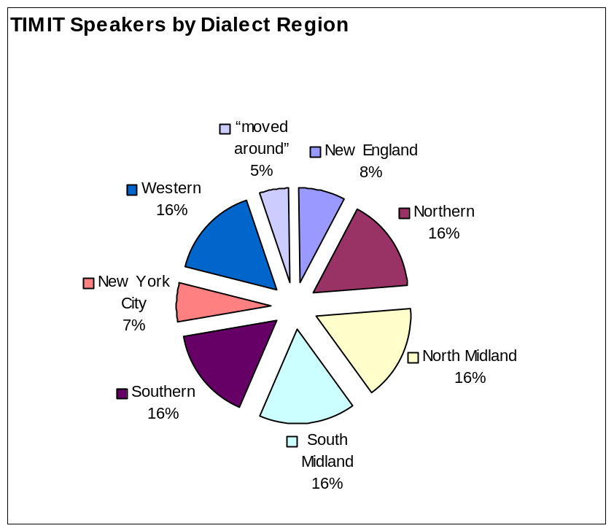
Figure 3: Speaker Breakdown by Region. (Total number of speakers= 630). Map detailing various geographical regions[6]

Solving the problems

In order to reduce the number of redundant definitions in the dictionary, two methods were investigated. The first, called “skimming,” simply edits out and deletes low-frequency transcriptions. This method defined a threshold based on the most commonly occurring pronunciations. Anything below this threshold is removed from the dictionary. The second method, called “percentaging,” encodes the frequency that each pronunciation was encountered into the definitions themselves, which a speech recognizer can use to modify its recognition network.

Methodology:

As mentioned earlier, the dictionary was created by examining all the speech transcriptions during training mode. The original system just added all of the different combinations of word and phonemes into the system. The new method does the same thing, except that it keeps a counter of how many times each combination occurred. We can use these counts to perform either skimming (removal of low-occurrence pairs), or percentaging (placing percentage occurrence information with the data). This paper examines the accuracy of skimming alone, percentaging alone, and finally skimming first and then making percentages. This spreads the percentage from the erroneous definitions out among all the other definitions that were above a specified threshold.
Figure 4: The process of modifying the dictionary

1 about ax b ae t
2 about ax b ah
4 about ax b aw d
17 about ax b aw t
1 about b ah
1 about b aw
An example of a dictionary before we apply a method: Clearly, “about ax b aw t” is the most commonly given pronunciation, and so it should be given highest weight, whereas definitions “bah” and “baw” should just be erased.
Skimming
4 about ax b aw d
17 about ax b aw t
Percentaging
3.85% about ax b ae t
7.69% about ax b ah
15.38% about ax b aw d
65.38% about ax b aw t
3.85% about b ah
3.85% about b aw
Examples of dictionaries after we apply a method:
Here we have skimming out all but the most frequently occurring observations.

Here we have inserted the frequency of each pronunciation as a function of the whole.

- results and analysis
The two systems of dictionary making were tested independently, and then with the 2-step method.
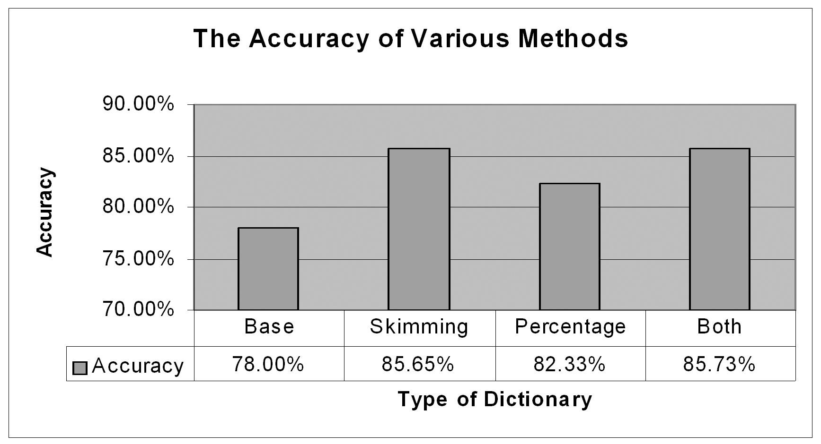
Table 4. Test Results
According to Table 4, skimming provided a much larger accuracy gain than did percentage. When the two were used simultaneously, percentage just added a very slim increase in accuracy to the Skim method.
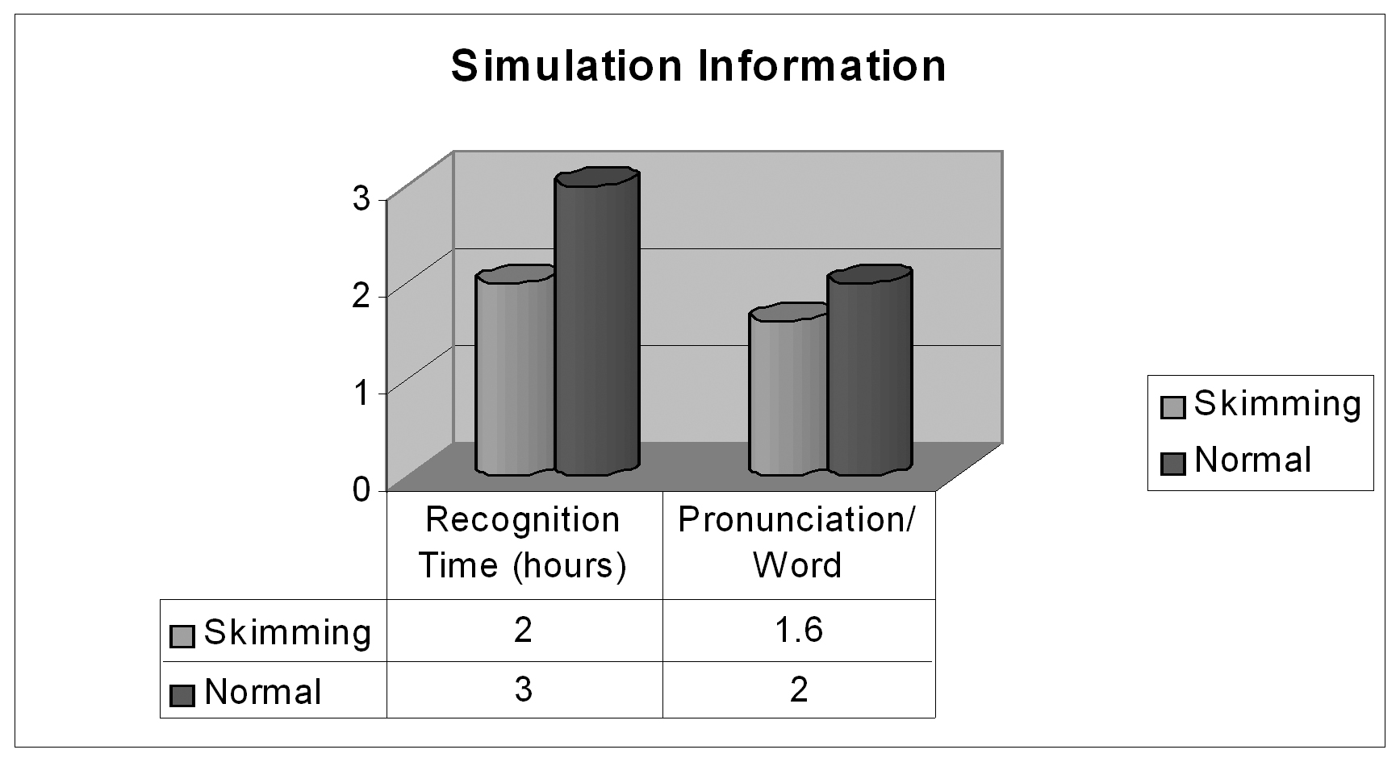
Table 5. Simulation Test Results
Another unexpected bonus of using the skimming method is a reduction in required recognition time. Since there are fewer possible recognition sequences, the computer can process each speech fragment more easily. At optimal skimming (30%), the test took only 2 hours, rather than 3, a 33% reduction in time. Furthermore, at this level of skimming, there were an average of 1.6 pronunciations per word, as opposed to 2.0 pronunciations without skimming.

5- conclusions

Since many people speak in different ways, it is expected that having a large dictionary, which is inclusive of all pronunciation and dialectic differences, would be a valuable aid to recognition. However, this paper shows that this is not always the case. Instead, multiple pronunciations must be taken in moderation, so that a balance is found between being inclusive of speakers and of conforming to the limitations of a computerized recognition system. Yet, our results show that multiple pronunciations are important to have, since our maximum accuracy comes at 1.6 pronunciations/word.
Furthermore, a hand tailored dictionary would be the most effective, because a conscious decision could be made about which words deserve multiple pronunciations, and which pronunciations are simply transcription or speaker errors. However, given the size of the dictionary (13000 entries), a computerized method is much more practical. Yet for certain specialized Speech Recognition applications, a hand-tailored dictionary would be feasible, and likely most effective.

6- references
  - Mohajer, K., Zhong-Min Hu, Pratt, V., Time Boundary Assisted speech recognition. International Journal of Information Fusion (Special Issue on Multi-Sensor Information Fusion For Speech Processing Applications).
  - Rabiner, Juang, Fundamentals of speech recognition, Ch6, Prentice Hal Signal Processing Series, New Jersey, 1993.
  - Young, Evermann, Kershaw, Moore, Odell, Ollason, Valtchev, Woodland, The HTK Book, Ch5, Cambridge University Engineering Department, 2001-2002.
  - Garofolo, Lamel, Fisher, Fiscus, Pallett, Dahlgren, TIMIT Printed Documentation, Ch5, U.S. Depart. Of Commerce, 1993.
  - Hain, T., Woodland, P.C., Evermann, G. et al. New features in the CU-HTK system for transcription of conversational telephone speech. Acoustics, Speech, and Signal Processing, 2001. Proceedings. (ICASSP '01). 2001 IEEE International Conference on, Vol.1, Iss., 2001. Pages:57-60 vol.1
  - Culicover, Peter. Lecture: An Introduction to Language in the Humanities. Spring 2002
http://www.ling.ohio-state.edu/~culicove/H201/Language%20variation.pdf

